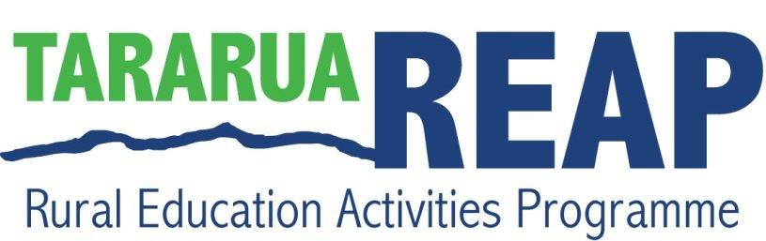

REAP what you Sew!

Do you want to improve your sewing skills?

REAP what you Sew classes give you an opportunity to get confident with many techniques, from basic sewing skills to drafting patterns. Sew machines available.

**Tutor: Billy Gordon**

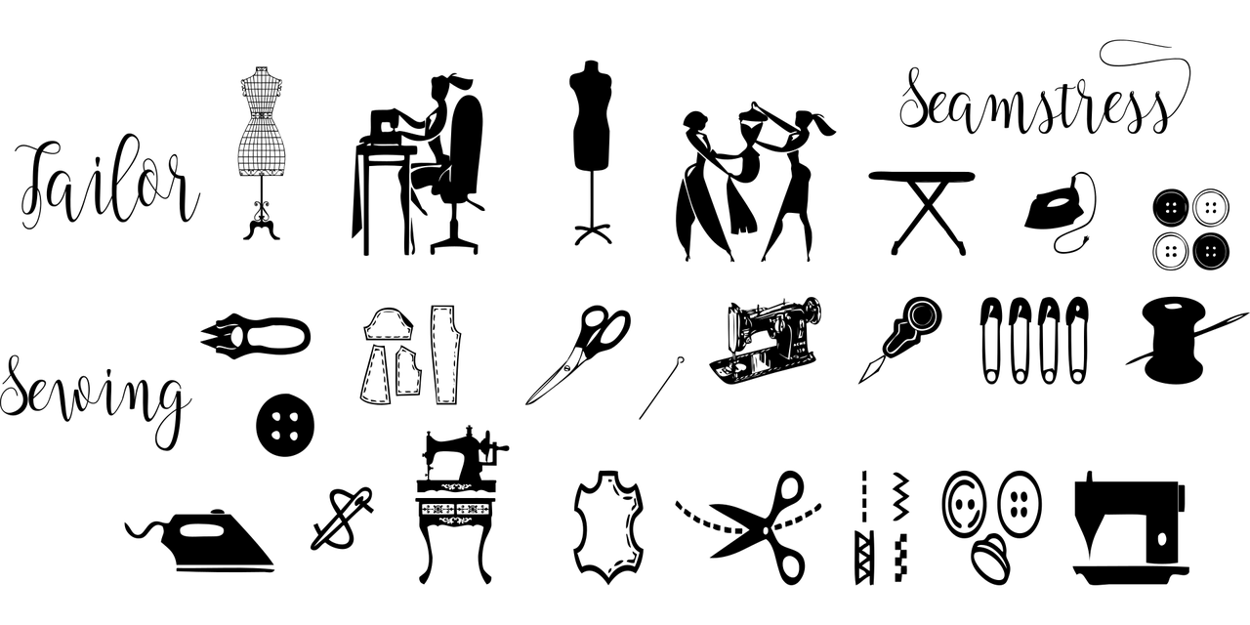

**When:**

Mondays starting 3rd of May – 5th July

9:30am – 12:30pm

**Where:**

Brackenbury Gallery Woodville

Koha appreciated.

**To register contact Tararua REAP**